where are the robots
Challenge: where are the robots
Category: Web Exploitation
Difficulty: Easy

In the context of picoCTF and web security, the "robots" aren't physical machines—they are the search engine crawlers (like Googlebot) that index the internet. The "gate" they use is a file called robots.txt.

How to get the Flag
Once you see a "Disallowed" path in the robots.txt file, copy that path and paste it into your browser's address bar in place of /robots.txt.
Step-by-Step:
- Go to site.com/robots.txt.
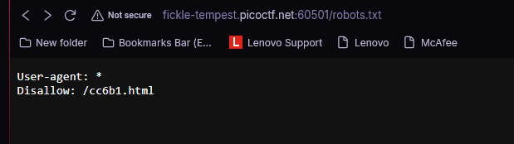
- Find the line Disallow: /secret-page.html.
- Go to site.com/secret-page.html.
- The flag (or the next part of your scavenger hunt) will be waiting there.
